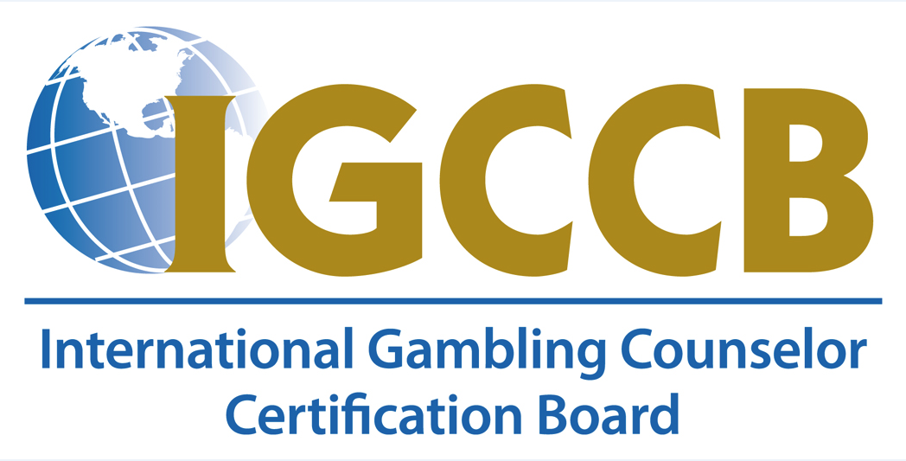

**IGCCB CONTINUING EDUCATION TRAINING PROGRAM**

**INITIAL AND RENEWAL APPLICATION**

Thank you for your interest in providing training programs and continuing education for the International Gambling Counselor Certification Board (IGCCB) certifications and certificates. The Board reviews and approves training program applications for all of our certifications and certificates. Our certifications and certificates require in-depth educational content to uphold the highest standards for professionals in the gaming and gambling disorder fields. The purpose of requesting approval is to ensure the training programs provide educational content that matches our educational training outlines. By seeking approval, your training program will be IGCCB certified and professionals can attend your trainings with confidence as they pursue or continue to maintain their certifications.

We will review all training programs, not individual providers, to determine the following:

1. The contents of the program correspond with our required educational outline
2. The presenter/trainer has sufficient knowledge and expertise in the topics being taught
3. The training uses up-to-date research and other evidence-based information that promotes competency in the fields of gaming and gambling disorders
4. The training program meets adult learning instructional design
5. Quizzes and/or Post Tests evaluate the individual attendees’ mastery of knowledge
6. Homework or other assignments further the knowledge to application for the individual attendees
7. And the training programs increase the number of professionals learning about or pursuing certification in the fields of gaming and gambling disorders

The approval covers the training program for 12-months after the approval date. All approved training programs will be listed on the IGCCB website with a link to the Organization/Presenter website for more information and registration. IGCCB is not responsible for answering questions related to any training programs.

Included in the application pack are the application form, fee schedule, and educational crosswalk form that corresponds with each certification. Please allow 4-6 weeks for the IGCCB to process your application. Email [training@igccb.org](mailto:training@igccb.org) with any questions.

Sincerely,

IGCCB Training Approval Committee

**Introduction**

Thank you for your interest in providing training programs that support the IGCCB training requirements for its certifications and certificates. The IGCCB reviews and approves all types of training programs that meet our requirements for Continuing Education (CE). The purpose of this approval process is to maintain a high standard of training quality, across the globe, that promotes the most up-to-date and evidence-based information to all attendees and members.

We charge by the CE Hour depending on your membership (ICGC, ICOGS, IGDC, BACC, CLERGY LAY MINISTER) with the IGCCB. $10 for non-members and $7 for members. *For example: Clergy 12-hour course is $84 when trainer is IGCCB or $120 when trainer is not IGCCB certified.* There will be an opportunity of 2 renewals with one initial application before needing to reapply (every 3 years).

**Training Approval Requirements (Summary)**

Please submit the following for review/approval:

* Course Title
* Course Description
* Presenter(s) Names and credentials
* Presenter(s) CV
* Language format (English, French, etc.)
* Course Length (1+, 15, 30, or 60 hours)
* Designated Certification or Certificate (ICGC, ICOGS, IGDC, Clergy)
* Training Objectives and Learning Outcomes
* Training Features
  + Video
  + Slides
  + Quizzes
  + Case formulation
  + Synchronous / Asynchronous (Instructor-led or Self-paced)
  + Homework and/or other project-based learning
* Completed Crosswalk to Training Outline for the certification or certificate
* Any other features or services provided (Study group, BACC meetings, etc.)
* Platform used for the course, if applicable

Examples include: Zoom, Thinkific, Teachable, Canvas

* Post-Test
* Course Evaluation that includes instructor evaluation and content evaluation

**IGCCB CONTINUING EDUCATION TRAINING PROGRAM**

**INITIAL AND RENEWAL APPLICATION**

|  |  |  |  |  |  |  |  |  |  |  |  |  |
| --- | --- | --- | --- | --- | --- | --- | --- | --- | --- | --- | --- | --- |
| APPLICANT INFORMATION | | | | | | | | | | | | |
| Contact Name: | | | | | | | | | | | | |
| Are you applying as the Trainer/Presenter? | | | | | | | | | | Yes  No | | |
| Are you applying on behalf of the Trainer/Presenter? | | | | | | | | | | Yes No | | |
| Job Title: | | | | | | | Email: | | | | | |
| Phone: | | | | | | | Work  Cell | | | | | |
| Is the Presenter a member of IGCCB?  Yes  No | | | | | | | What certifications does the presenter have? | | | IGCG-I.  CLERGY  ICGC-II  BACC  IGDC | | |
| ORGANIZATION INFORMATION | | | | | | | | | | | | |
| Organization Name: | | | | | | | | | | Website: | | |
| Address: | | | | | | | | | | | | |
| City/Town: | | | | | | State/Province: | | | | | | Zip: |
| Country: | | | | | | | | | | | | |
| TRAINING INFORMATION | | | | | | | | | | | | |
| Course Title: | | | | | | | | | | | | |
| Brief Course Description: | | | | | | | | | | | | |
| Is this training: | | | | Initial Application | | | | | | Renewal Application | | |
| Virtual (online/webinar) | | | | Start Date: | | | | | | Platform/Software: | | |
| In-Person | | | | Training Date(s): | | | | | | Location: | | |
| Frequency of the training: | | | | One-Time | | | | | | Recurring | | |
| Training for designated Certification or Certificate: | | | | | | | | | | | | |
| CLERGY LAY/MINISTER | | | | | | | | |  | | | |
| Total hours/CEs: | | | | or | | | | 24 | | | | |
| REQUIRED PRESENTATION MATERIALS | | | | | | | | | | | | |
| *Please provide documentation from the following list in a separate document:* | | | | | | | | | | | | |
| Presenter(s) CV or Resume | | | | | | | | | | | | |
| Training Title and Description including educational offering (workshop, conference, webinar, etc.) | | | | | | | | | | | | |
| Training Objectives and Learning Outcomes | | | | | | | | | | | | |
| *Training Features*: | | | Video, slides  Quizzes  Case formulation and presentation  Homework and other project based learning | | | | | | | | Virtual Only:  Synchronous (Instructor-Led)  Asynchronous (Self-Paced) | |
| *Virtual Only:* | You will need to provide a guest account/login to the course for verification | | | | | | | | | | | |
| If virtual, please provide a link to log into the course: | | | | | | | | | | | | |
| Completed Educational Crosswalk Form (see Education Crosswalk form) | | | | | | | | | | | | |
| Language: | | English | | | Other: | | | | | | | |
| Post-Test  Course Evaluation that includes instructor evaluation and content evaluation | | | | | | | | | | | | |
| TRAINING PROGRAM AGREEMENT | | | | | | | | | | | | |
| *Please initial each statement indicating that you are in agreement:* | | | | | | | | | | | | |
| I/We agree to follow the IGCCB educational training outline in our program | | | | | | | | | | | | |
| I/We agree to promote the importance of IGCCB certifications and certificates in the problem gaming and gambling fields. | | | | | | | | | | | | |
| I/We agree to utilize trainers and presenters whose credentials and qualifications demonstrate expertise and knowledge in gaming and gambling disorders | | | | | | | | | | | | |
| I/We agree that our trainers possess work experience that make them relevant to the topics they are presenting | | | | | | | | | | | | |
| By initialing the statement above, and signing below, we agree to provide educational programming that upholds the IGCCB criteria for meeting the educational requirements of designated certificates and certifications. | | | | | | | | | | | | |
| Electronic Signature: | | | | | | | | | | Title: | | |
| Print Name: | | | | | | | | | | Date: | | |

|  |  |  |
| --- | --- | --- |
| IGCCB CONTINUING EDUCATION TRAINING PROGRAM | | |
| APPLICATION FEE (choose one) | | |
| $7/CE x       hours (7 x 12 hours = $84) | | IGCCB Certified Professional |
| $10/CE x       hours (10 x 12 hours = $120) | | Non-IGCCB Professional |
| Total:       amount included | | |
| PAYMENT | | |
| Please provide name of authorized person that can pay invoice by debit/credit card. Invoice will be emailed to authorized person. | | |
| Authorized Person: | | |
| Email: | | |
| Electronic Signature: | Date: | |

### **International Clergy Lay Minister Training Outline (CLERGY) (12 hours)**

Course Name:

| **Educational Topic** | **Location in the Training (PowerPoint, Exercise, Quiz, Video, etc.)** | **Additional Comments** |
| --- | --- | --- |
| 1. BASIC KNOWLEDGE OF PROBLEM AND DISORDERED GAMBLING |  | Powerpoint  Exercises/ Activity / Assignment  Videos  Other |
| * 1. History of Gambling and Definition of Gambling and Disordered Gambling |  | Powerpoint  Exercises/ Activity / Assignment  Videos  Other |
| * 1. Subtypes & Pathways Models |  | Powerpoint  Exercises/ Activity / Assignment  Videos  Other |
| * 1. Screening Tools (SBIRT, Lie/Bet, etc.) |  | Powerpoint  Exercises/ Activity / Assignment  Videos  Other |
| * 1. Stages of a Gambling Problem |  | Powerpoint  Exercises/ Activity / Assignment  Videos  Other |
| * 1. Public Awareness and Perception of Gambling; Impact of Advertising      1. Advertising Impact      2. Current Trends (sports betting, gaming, virtual formats) |  | Powerpoint  Exercises/ Activity / Assignment  Videos  Other |
| * 1. Cultural Diversity and Tailored Prevention |  | Powerpoint  Exercises/ Activity / Assignment  Videos  Other |
| * + 1. Youth     2. Older Adults     3. Racial and Ethnic Diversity     4. Veterans     5. Women |  | Powerpoint  Exercises/ Activity / Assignment  Videos  Other |
| * 1. Spiritual Issues: Guilt, Shame, |  | Powerpoint  Exercises/ Activity / Assignment  Videos  Other |
| * 1. Connecting/ Disconnecting with Reality and Responsibilities |  | Powerpoint  Exercises/ Activity / Assignment  Videos  Other |
| 1. GAMBLING AS ADDICTION |  | Powerpoint  Exercises/ Activity / Assignment  Videos  Other |
| * 1. Similarities and differences with Substance Use Disorders |  | Powerpoint  Exercises/ Activity / Assignment  Videos  Other |
| * 1. Suicide and Gambling |  | Powerpoint  Exercises/ Activity / Assignment  Videos  Other |
| * 1. Co-occurring disorders |  | Powerpoint  Exercises/ Activity / Assignment  Videos  Other |
| * 1. Recovery Signs and Problems |  | Powerpoint  Exercises/ Activity / Assignment  Videos  Other |
| * + 1. Financial Issues |  | Powerpoint  Exercises/ Activity / Assignment  Videos  Other |
| * + 1. 12 Step Recovery |  | Powerpoint  Exercises/ Activity / Assignment  Videos  Other |
| * + 1. Recovery Oriented Systems of Care |  | Powerpoint  Exercises/ Activity / Assignment  Videos  Other |
| * + 1. Stages of Change |  | Powerpoint  Exercises/ Activity / Assignment  Videos  Other |
| * + 1. Evidence-Based Treatment (CBT, Self-Regulation, Harm Reduction) |  | Powerpoint  Exercises/ Activity / Assignment  Videos  Other |
| Peer Recovery Models (GA, GAM-ANON, Smart Recovery) |  | Powerpoint  Exercises/ Activity / Assignment  Videos  Other |
| How to Have the Conversation with the Gambler/Family Support |  | Powerpoint  Exercises/ Activity / Assignment  Videos  Other |
| 1. Developing Community Wellness and Spiritual Outreach in Problem Gambling/Gambling Disorder and Co-Occurring Mental Health Concerns |  | Powerpoint  Exercises/ Activity / Assignment  Videos  Other |
|  |  |  |
| SPIRITUAL (4 hours) |  |  |
| Module 1: Guilt, Shame, Connecting  Disconnecting with Reality and Responsibilities |  | Powerpoint  Exercises/ Activity / Assignment  Videos  Other |
| Module 2: Secrecy and Trust Dynamics |  | Powerpoint  Exercises/ Activity / Assignment  Videos  Other |
| Forgiveness/Trust/Doubt/Fear |  | Powerpoint  Exercises/ Activity / Assignment  Videos  Other |
| Module 3: Concepts of Hope and New Life, Making Amends, Twelve Steps |  | Powerpoint  Exercises/ Activity / Assignment  Videos  Other |
| Spiritual Implications and Responses |  | Powerpoint  Exercises/ Activity / Assignment  Videos  Other |
| Steps 4 and 5--Perspectives for the Faith/Spiritual or Indigenous Healer |  | Powerpoint  Exercises/ Activity / Assignment  Videos  Other |
| Module 4: Meaning and Purpose, Framework for Recovery |  | Powerpoint  Exercises/ Activity / Assignment  Videos  Other |
| Faith-based/Spiritual and Indigenous Healing Addiction Ministries |  | Powerpoint  Exercises/ Activity / Assignment  Videos  Other |

NOTE: 100% of this outline needs to be met if submitting for the entire 24 program hours